**Project Design Phase-II**

**Technology Stack (Architecture & Stack)**

|  |  |
| --- | --- |
| Date | 15 April 2025 |
| Team ID | SWTID1743870576 |
| Project Name | SpendSmart: Your Personal Finance Companion |
| Maximum Marks | 4 Marks |

* **Technical Architecture:**

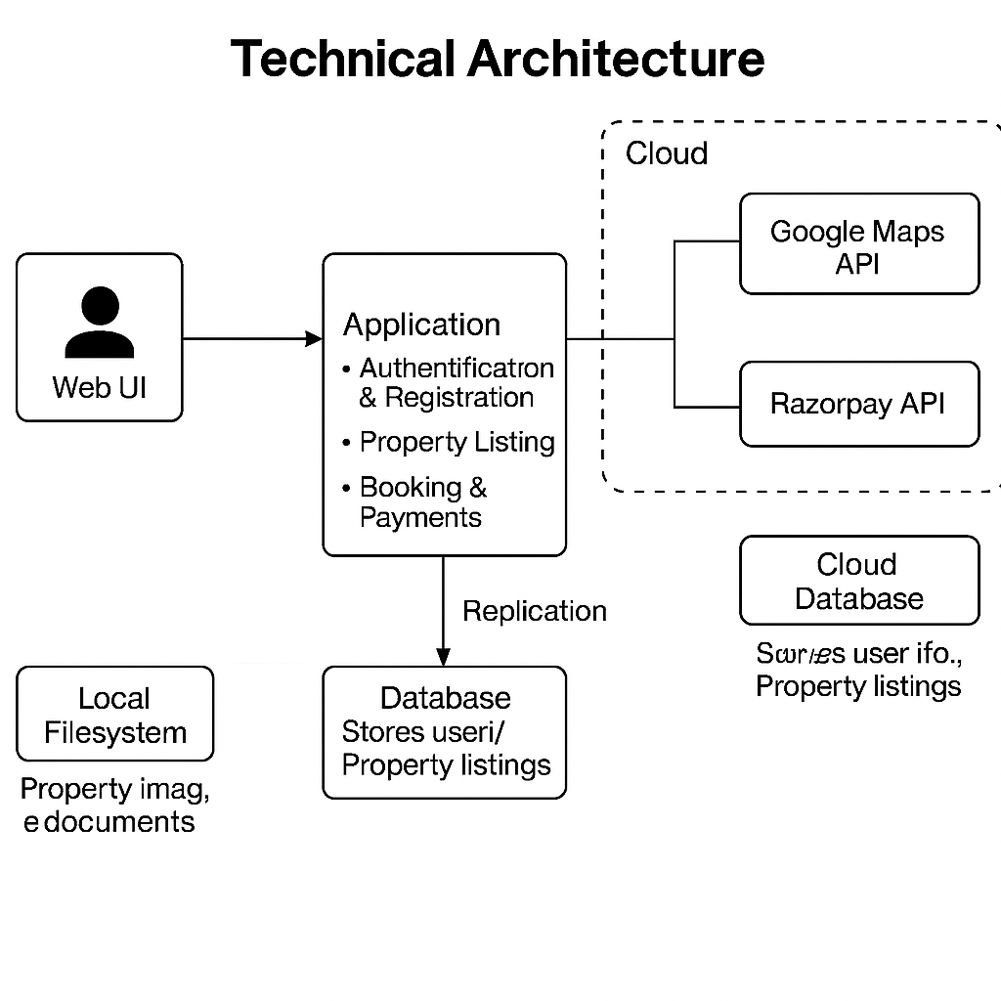

**Table-1: Components & Technologies:**

|  |  |  |  |
| --- | --- | --- | --- |
| **S.No** | **Component** | **Description** | **Technology** |
| 1 | User Interface | Web UI and responsive mobile web for expense tracking, dashboard, and analytics | React.js, HTML, CSS, JavaScript |
| 2 | Application Logic-1 | User authentication & registration (secure login, JWT-based sessions) | Node.js / Express.js, JWT |
| 3 | Application Logic-2 | Transaction management: add, edit, delete, categorize income and expenses | Node.js / Express.js |
| 4 | Application Logic-3 | Analytics and visualization: generate charts, summaries, and financial insights | Node.js / Express.js, Chart.js |
| 5 | Database | Stores user profiles, categorized transactions, and summaries | MongoDB (NoSQL) |
| 6 | Cloud Database | Cloud-hosted version for scaling and high availability | MongoDB Atlas |
| 7 | File Storage | (Optional/future) Storage for receipts or export files | Local Filesystem / Cloud Storage |
| 8 | External API-1 | (Optional/future) Bank or wallet integration for auto-import of transactions | Bank API / Plaid API (future) |
| 9 | External API-2 | (Optional/future) Currency conversion or financial news integration | Exchange Rate API (future) |
| 10 | Visualization Library | Data visualization for charts and dashboards | Chart.js |
| 11 | Version Control | Source code management and team collaboration | GitHub |
| 12 | Infrastructure | Cloud deployment of frontend, backend, and database | Vercel (frontend), Render (backend), MongoDB Atlas (database) |

**Table-2: Application Characteristics:**

|  |  |  |  |
| --- | --- | --- | --- |
| **S.No** | **Characteristics** | **Description** | **Technology** |
| 1 | Open-Source Frameworks | MERN stack for full-stack web development | React.js, Node.js, Express.js, MongoDB |
| 2 | Security Implementations | JWT authentication, HTTPS, password hashing, secure API endpoints | JWT, bcrypt, HTTPS, Helmet.js |
| 3 | Scalable Architecture | Modular codebase, cloud deployment, supports horizontal scaling | MERN stack, Vercel, Render, MongoDB Atlas |
| 4 | Availability | Cloud-hosted, high uptime, accessible from any device | Vercel, Render, MongoDB Atlas |
| 5 | Performance | Fast API response, efficient data rendering, real-time updates | Node.js, Express.js, React.js |
| 6 | Usability | Clean, intuitive UI, responsive design for desktop and mobile | React.js, CSS, Material UI |
| 7 | Data Visualization | Interactive charts and dashboards for financial insights | Chart.js |
| 8 | Extensibility | Easy integration of new features (e.g., bank APIs, mobile app, advanced analytics) | Modular MERN stack, RESTful APIs |

**References:**

[**https://c4model.com/**](https://c4model.com/)

[**https://developer.ibm.com/patterns/online-order-processing-system-during-pandemic/**](https://developer.ibm.com/patterns/online-order-processing-system-during-pandemic/)

[**https://www.ibm.com/cloud/architecture**](https://www.ibm.com/cloud/architecture)

[**https://aws.amazon.com/architecture**](https://aws.amazon.com/architecture)

[**https://medium.com/the-internal-startup/how-to-draw-useful-technical-architecture-diagrams-2d20c9fda90d**](https://medium.com/the-internal-startup/how-to-draw-useful-technical-architecture-diagrams-2d20c9fda90d)